Exploring the SmartRecruiters Product Portfolio
Objective
After completing this lesson, you will be able to identify the components of the SmartRecruiters ecosystem.
Introduction to SmartRecruiters
SmartRecruiters offers a comprehensive solution for intelligent hiring, addressing the challenges of modern talent acquisition. The partnership between SAP and SmartRecruiters leverages AI, skills, and data-driven insights to enable organizations to attract, hire, and onboard the right talent, aligning every hire with business and workforce goals.
SmartRecruiters’ powerful, user-friendly interfaces and mobile capabilities complement SAP SuccessFactors’ robust HR tools – improving decision making, reducing time-to-hire, and providing a better experience for candidates, recruiters, and hiring managers.
Key Benefits of SmartRecruiters
SAP SuccessFactors and SmartRecruiters power intelligent hiring for the future, enabling organizations to attract, hire, and onboard the right talent. With AI, skills, and insights at the center of hiring, SmartRecruiters can help organizations make smarter hiring decisions that drive better business outcomes while offering advanced automation and a user experience that resonates with both recruiters and candidates.
- Building a Skilled Workforce: The integration facilitates the development of a workforce equipped with the skills necessary for future success. AI-enabled hiring processes ensure that organizations can identify and acquire individuals with the right skill sets.
- Enhanced Candidate Experience: The integrated solution delivers inspiring experiences for candidates, empowers recruiters, and engages top talent from the initial stages of the hiring process. Personalized career sites, targeted talent pools, and intuitive recruiting and onboarding processes contribute to a positive candidate journey.
- Data-Driven Decision Making: AI-driven insights enable faster and smarter hiring decisions at every step of the recruitment process. By leveraging analytics and talent intelligence, organizations can identify the best candidates, pinpoint hiring bottlenecks, and optimize talent processes.
- Alignment with Business Goals: The integration connects hiring with workforce planning and talent management, ensuring that every hire contributes to the overall success of the business. Insights derived from a unified skills foundation and integrated SAP Business Suite facilitate strategic workforce planning.
Key Features of SmartRecruiters
The SmartRecruiters ecosystem is built around several core components, each designed to streamline and enhance the hiring process.
SmartOS: The Operating System for Hiring
At the heart of it all is SmartOS, the operating system for hiring. SmartOS encompasses Applicant Tracking System (ATS), Candidate Relationship Management (CRM), ​Onboarding, Offer Management, and Job Postings. It's built on a secure and scalable architecture with open APIs, ensuring flexibility and integration with other systems.
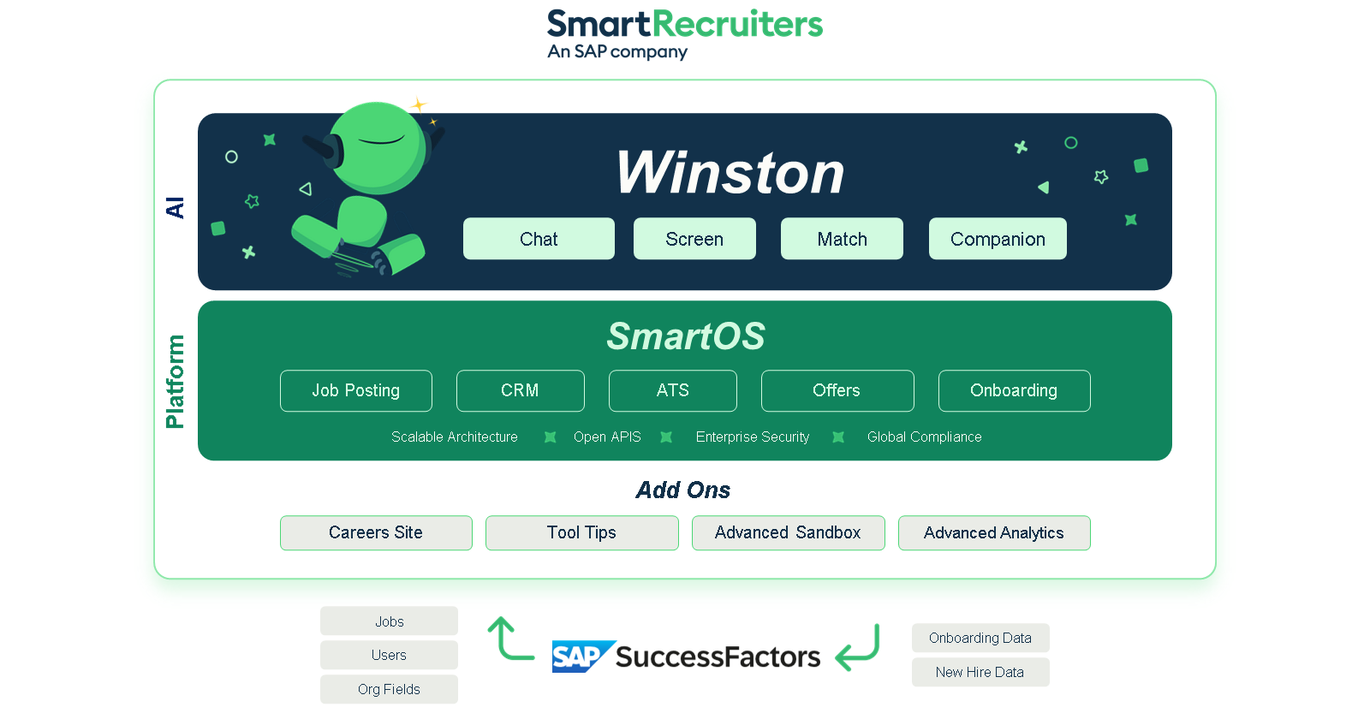
Applicant Tracking System (ATS)
The ATS provides the essential infrastructure for managing candidates from application through selection. It features customizable workflows that can be tailored to match any specific hiring process, ensuring compliance and consistency. Recruiters and hiring managers benefit from streamlined collaboration tools that enable real-time feedback and shared evaluations within a candidate's profile. A critical efficiency feature is Dynamic Scheduling, which automates the interview booking process by integrating directly with calendars and allowing candidates to self-schedule, dramatically reducing administrative time. The system maintains a complete, secure history of all candidate data and communications.
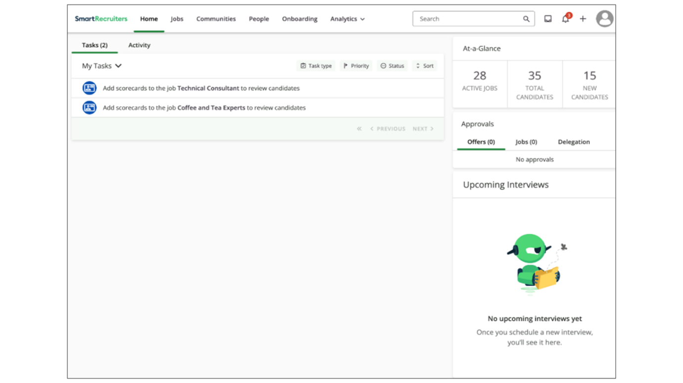
Job Postings & Distribution
SmartRecruiters simplifies the process of attracting talent by providing centralized job distribution. Recruiters can create and publish job listings to a vast network of ​global job boards, social media sites, and the company's branded career site from a single interface. Jobs can be distributed to job boards the customers already have contracts with or to brand new job boards that they can purchase one-off credits directly from the SmartRecruiters marketplace. The platform supports sophisticated programmatic advertising capabilities, allowing companies to strategically manage budget and placement to ensure their roles reach the right candidates, improving both applicant volume and source-of-hire tracking.
Offer Management
The final stage of the hiring process is optimized with dedicated Offer Management tools. Recruiters can quickly generate and customize offer letters using templates, with automated, configurable offer approval workflows managing the necessary signoffs, ​including mobile access to eliminate bottlenecks. The process is finalized with seamless e-signature integration (for example, DocuSign), enabling candidates to accept and sign documents digitally, which accelerates time-to-hire and enhances the final candidate experience.
Candidate Relationship Management (CRM)
The native CRM functionality differentiates SmartRecruiters by focusing on proactive sourcing and talent engagement. It allows organizations to build and manage segmented Talent Pools, or communities of passive candidates categorized by skills or future needs. Recruiters use this feature for recruitment marketing, deploying targeted campaigns and scheduled messaging (including SMS​ or WhatsApp​) to nurture relationships. Since the CRM is built on the same system as the ATS, there is a unified candidate profile, ensuring a seamless flow of data from lead engagement to active application to nurture relationships.
Winston: The AI Powerhouse
Winston, the AI layer within SmartRecruiters, enhances SmartOS by automating repetitive tasks and providing personalized insights. Winston is not a single product but a suite of AI capabilities, including:
- Winston Chat: Provides real-time support to candidates through conversational AI.
- Winston Screen: Analyzes candidate responses to accelerate the screening process.
- Winston Match: Drives talent matching by analyzing skills and resumes.
- Winston Companion: Streamlines day-to-day workflows for recruiters.
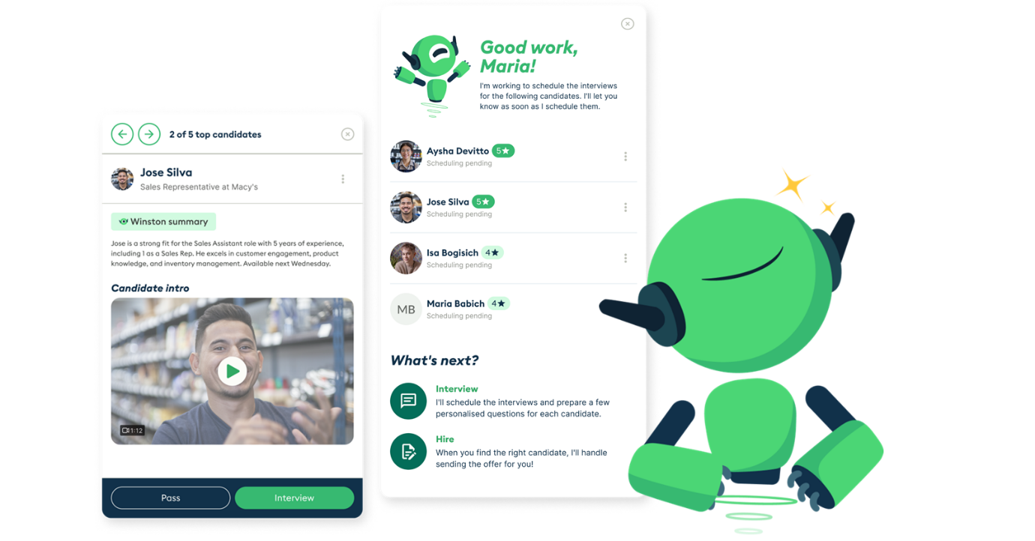
​Surrounding the core are add-ons like​ advanced​ career sites​ options​ (Smart​Attrax​​​), advanced analytics (Smart Analytics), and sandboxes (Smart Sandbox), which extend the functionality of SmartOS. SmartOS connects seamlessly with HCM systems, ensuring smooth data flows across jobs, users, and onboarding. Additionally, customers can access over 350 marketplace integrations with partners like LinkedIn and Indeed.
Caution
Core add-on features (such as SmartAttrax, Smart Analytics, Smart Sandbox, SmartTips, and SmartSite) may change based on business requirements. These are not included by default.
SmartOS Modules (Add Ons)
These premium add-on products do not come by default with SmartOS, but are structured within the Smart family of products.
SmartOS Modules (Add Ons)
Smart OS Module (Add On) | Description
SmartAttrax | Enterprise-grade career site solution.
SmartTips | In-app guidance tools for platform usage improvement.
SmartSite* | Simple career site builder, powered by Wix.
SmartAnalytics | Premium analytics suite, powered by Visier.
SmartSandbox | Advanced sandbox environment for testing.
Note
*SmartSite is coming in a future release.
Summary
- SmartOS is the core operating system for hiring, encompassing ATS, CRM, Onboarding, Offer Management, and Job Postings.
- Winston AI enhances SmartOS with capabilities like chat, screening, matching, and workflow automation.
Personalize your learning.
Log in and track your growth over time.
RegisterLog in
Was this lesson helpful?
YesNo
Next lesson

Learning

ntroducing SmartRecruiters Marketplace
Objective
After completing this lesson, you will be able to use SmartRecruiters Marketplace to find, request, and manage integrations to optimize the hiring process.
The SmartRecruiters Marketplace
The SmartRecruiters Marketplace is a comprehensive ecosystem of integrations and service partners designed to simplify hiring for SmartRecruiters customers. It acts as a self-service, one-stop shop where customers can connect the tools they need for various aspects of the hiring process, including ​​candidate assessments, background checks, HRIS and payroll systems, and CRM platforms.
The SmartRecruiters Marketplace simplifies hiring by centralizing access to a wide range of vendors and integrations. This leads to:
- Simplified Management: Centralized access to various hiring tools and services.
- Faster Setup: Quick and easy integration setup that seamlessly fits into existing workflows.
- Improved Reporting: Access to consolidated reporting and vendor data in one location.
Note
Resources found in the SmartRecruiters Marketplace will eventually be moved into the SAP Partner Portal.
Marketplace Home Page
Accessing the Marketplace is straightforward. Users can navigate directly from within SmartRecruiters by selecting Marketplace from the main navigation menu or by visiting Marketplace.
Once on the Marketplace page, users will see a default view of all partners. However, they can filter by partner type (technology, services, or AI) using the provided buttons. The left-hand side of the page offers a range of filters and a keyword search function to help users narrow down their options.
Key Search and Filter Options:
- Keyword Search: Search for specific partners by name (for example, search for "HireVue").
- Objectives: Filter partners based on specific hiring objectives, such as improving hiring velocity or developing employer branding.
- Categories: Filter by category, such as attracting, selecting, hiring, management and reporting, integration middleware, or AI.
- Advisory Type: Filter based on the type of advisory services offered.
- Languages: Filter by supported languages.
- Data Centers: Filter by data center location.
- Target Customer Size: Filter by the partner's target customer size.
- Integration Costs: Filter by integration cost.
- Sorting: Sort partners by newest, alphabetically, or most reviewed.
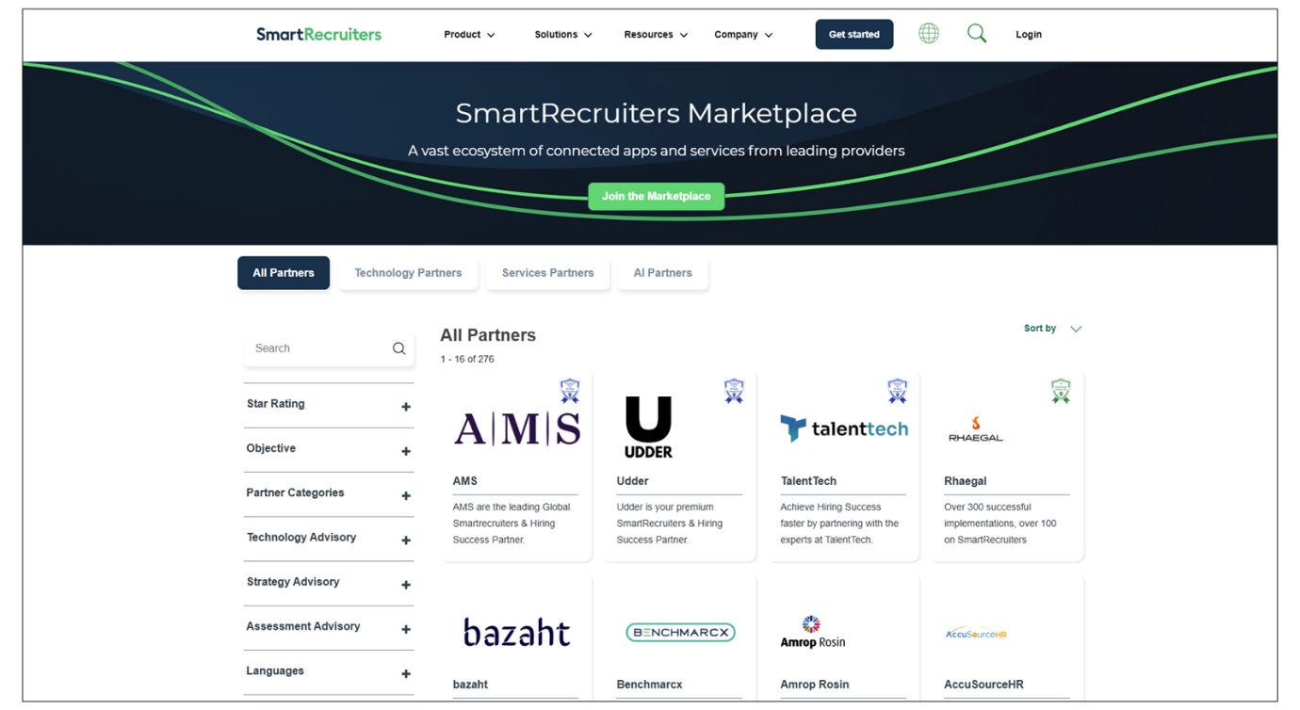
Integration Request Process and Set Up
Once a customer finds a relevant integration, they can navigate to the partner's page to review additional information about the integration and its features. From there, they can request to have the integration set up.
The request process involves providing basic information about the customer and their company, as well as specifying the type of request (for example, introduction to the partner or setup of an existing contract). Once the request is submitted, the SmartRecruiters Marketplace team works with the customer and the partner to activate the integration.
As a consultant, you don't need to be an expert on every vendor in the Marketplace. However, you should be familiar with the available options so you can guide customers in the right direction. Encourage customers to begin the integration setup process early in their project to avoid last-minute delays. If a project scope includes a Marketplace item you lack details for, flag it to your Delivery Success Manager (DSM) or partner managers.
Most Marketplace integrations are self-service. However, some may require closer consultant awareness. These cases will be listed in the statement of work or order form, and separate guides and articles are available to support you.
Gain more insight into the SmartRecruiters Marketplace by watching the video below.
This video is for demonstration purposes. Any references made in this video to previous or later videos in this course (including titles, numbers, links, or sequence) may differ from the current course structure. Additionally, some functionalities shown may have evolved over time due to ongoing enhancements or business decisions.
Summary
- The SmartRecruiters Marketplace centralizes integrations and service partners, simplifying the hiring process for customers.
- Utilize the search and filter options within the Marketplace to efficiently find the right integrations based on objectives, categories, and other criteria.
- Requesting and setting up integrations is a straightforward process, with the SmartRecruiters Marketplace team providing support.
Was this lesson helpful?
YesNo
Hi, in this video, we're
going to take a quick look at the Smart Recruiters Marketplace. You'll learn what it is, why it
matters for customers, and the key things you need to know when
guiding customers through projects. The Marketplace is Smart
Recruiters ecosystem of integrations and service partners. It gives customers a self
-service, one-stop shop to connect the tools that they need for
hiring. The categories you can find there include job boards,
assessments, background checks, HRIS and payroll systems,
CRMs and many more. For customers, the marketplace
makes hiring simpler. Instead of juggling multiple vendors, everything is centralized
and easier to manage. Setup is quick, integrations
fit smoothly into workflows and they gain access to reporting
and vendor data all in one place. Let's take a quick look at the
marketplace in action so you can see how customers explore
integrations and connect with vendors. We can navigate to the
marketplace directly from SmartRecruiters by selecting marketplace
from the navigation menu or of course we can simply go to
marketplace.smartrecruiters.com. On the Marketplace page you'll
see it defaults to all partners but there are buttons available
so a customer can go and look specifically at technology
partners, services or AI partners. On the left hand side there are
filters and keyword search available so perhaps I am looking for a
specific partner so maybe HireVue and you'll see that as I start to type it
will bring up options or suggestions that I can go through and take a
look at. If I run the search on just HireVue you can see it's
brought me two results here so I can navigate through to that partner's
page where I can review additional information about the integration
itself and its features and this is where I can come through and request
that this integration gets set up. When I navigate to the request
page I'll simply need to add some simple information about who I
am and the company I'm working for and then the type of request.
So do I want an introduction to the partner because we're not
currently working with them or do I have an existing contract that
I want to go ahead and get set up in SmartRecruiters. So, they
simply fill in the details and submit and this gets handed to
our marketplace team who will then work with the customer and the
partner to get this in action. Back on the home page just taking
a look at some of the additional filter options you know maybe
you have a customer who has specifically said they would like
to improve their hiring velocity or develop their employer brand.
So you'll see there is objectives here that they can come through
and select one of these options for or multiple options and as I
select those then the applicable partners will be presented to
me. There is also the option to search by category so if they're
looking to attract, select, hire, management and reporting or
integration middleware or partners for AI they can come through
and select those options and additionally there is
categories here for the type of advisory they might be looking
for, languages, data centres, their target customer size and
also integration costs. So lots of filters here that they can narrow
down their search results if they're not sure what they're specifically
looking for and also the option to sort by the newest partners or
alphabetically or most reviewed. So super simple to navigate and
get those introductions set up so they can get those integrations
in place ready for their go live. As a consultant you don't need
to know every detail about each vendor but you should
be familiar with marketplace options so you can guide
customers in the right direction. It's also really important to
encourage customers to begin set up early in their project
to avoid last minute delays. If the project scope includes a
marketplace item you don't have details for, make sure to flag it
to your DSM or partner managers. Most marketplace integrations are
completely self-service. However, a few may require closer consultant
awareness. For those cases, you'll see these listed in the
statement of work or order form and separate guides and articles
are available to support you. And that's the overview of the
marketplace. Remember, your role is to point customers
in the right direction and most importantly encourage them
to set up integrations early to avoid any delays or last
minute rushes. Thanks for watching.

